LEARNING ACTIVITY 2

Data Preparation and Processing
North Quay Gifts | Online Retail II
CRISP-DM Phase Data Preparation
Team or participant | Submission date
Russel Emmanuel Ku Aguilar (2309131) · Damian Nicolas Sanchez Novelo (2109134) · Jonathan Abisai Velasco Martín (2309060) · Ángel Rivaldo Canché Chuc (2309030) · Bianca Alexandra Acosta Castellanos (2309001) | October 30, 2026

Reading note: Text in grey italics reproduces the instructions of the original template. Text in black contains the team’s results and answers, generated with the notebook “NB3 Data Preparation and Processing - Online Retail II.ipynb”.

Purpose
Implement two processing strategies and compare their effects on daily orders, units and revenue. Select a documented transactional version to continue with the construction of analytical datasets.

Resources and starting point
Retrieve online_retail_II.csv, the North Quay Gifts case and your Activity 1 diagnosis. Use Pandas and a visualization library. Do not start from an already filtered file that prevents rebuilding the excluded records.

I Initial preparation
1. Keep an original copy and assign every line a stable SourceRow before filtering. This key is used to trace decisions; it must not take part in the search for exact duplicates across the eight original columns.
2. Review Invoice, StockCode and Customer ID as identifiers and InvoiceDate as date and time. If you normalize Customer ID as CustomerID, document the equivalence. Keep missing customers as nulls, without inventing a shared key. Keep the original prices for calculation and comparison; round only the presented results.
3. Decide what to do with exact duplicates. Justify the decision with your diagnosis and apply it equally in both routes. Keep the count of additional copies and of retained lines. Document separately any other common exclusions, such as unparseable dates or non-numeric measures.
4. Keep lines without a customer when their transactional fields are usable for the global summary. Do not impute customers or descriptions to resolve cancellations. Separate the exceptions and record the reason for every exclusion. Apply common rules before comparing the routes.
Initial control | Result or decision
Original file and period | online_retail_II.csv (Chen, 2012): 1,067,371 lines × 8 columns. Period: 2009-12-01 07:45:00 to 2011-12-09 12:50:00 (604 dates with movements). Dec-2009 (21 days, up to the 23rd) and Dec-2011 (8 days, up to the 9th) are partial months. An untouched copy is kept and SourceRow = 1…1,067,371 is assigned before filtering.
Original lines and additional duplicates | 1,067,371 original lines; 34,335 additional exact copies (3.22%) in 32,907 groups (67,242 lines involved). SourceRow is not used when comparing the 8 columns.
Duplicate decision and rationale | Additional copies are excluded and the first occurrence (lowest SourceRow) is retained, identically in A and B. Rationale (Activity 1): they repeat all 8 columns, including the minute-level timestamp (e.g., invoice 489517, StockCode 21912); there is no line number or shipping evidence to tell a legitimate row from a double record, and keeping them would inflate units and revenue. Reversible: every copy is listed in registro_exclusiones.csv.
Other common exclusions and their counts | Unparseable dates: 0; non-numeric Quantity: 0; non-numeric Price: 0; null Invoice/StockCode: 0. Customer ID is normalized as CustomerID (nullable integer, 13085.0 → 13085); 235,151 lines without a customer are kept as nulls, with no imputed customers or descriptions. Prices are not rounded.
Common-base lines after those decisions | 1,067,371 − 34,335 − 0 = 1,033,036 lines in the common base.

Complete this document as a comparative report. Replace the fields and add your tables and figures. The notebook must keep both routes and allow the report to be rebuilt from the original file.

II Processing strategies

Route A Record exclusion
From the common base, exclude invoices whose Invoice starts with C, lines with Quantity ≤ 0 and lines with Price ≤ 0. Check that every retained line has positive quantity and price and lacks the C prefix. Report the counts per condition and also the total excluded, without double-counting lines that meet several conditions.
The retained lines are considered valid purchases for this exercise. Route A amounts represent gross sales of the retained purchases, before recognizing the credits of Route B; they do not represent profit or an audited financial statement.

Route B Credit recognition and reconciliation
Keep the same valid purchases as A and add the lines from the common base with a C prefix, Quantity < 0 and Price > 0. Keep their sign and their recorded date. Treat them as documented credits, even if you cannot identify an originating invoice. Their link to a purchase is investigated separately, as described on the next page.
Separate C lines with positive or zero quantity and non-positive prices as exceptions. Investigate negatives without C through their prices, descriptions and customer data. In the main comparison, keep them outside the commercial result unless there is sufficient evidence to classify them as a sales return. Quantify the set and justify its treatment; do not automatically turn it into positive sales.
This convention allows retained purchases to be compared with purchases net of recorded credits. Reconciliation describes the traceability of the credit; it does not by itself determine whether it is recognized. Report that part of net sales may include credits with no identified originating purchase.
Compute B on the movement date: keep the positive purchase and the negative credit once each. Do not additionally reduce the original purchase or move the credit to another date. If you explore a retrospective correction, present it as additional analysis, without mixing it into the main series.
Route control | A | B
Lines kept | 1,007,913 | 1,027,016
Lines excluded from the common base | 25,123 (primary reason: C prefix 19,104; Quantity ≤ 0 3,393; Price ≤ 0 2,626) | 6,020 (C exception 1; negatives without C 3,393; non-positive price without C 2,626)
Valid purchases kept | 1,007,913 | 1,007,913 (identical to A)
Negative C credits recognized | 0 (19,103 negative C lines excluded) | 19,103 lines in 8,291 C invoices
C exceptions and negatives without C | 3,394 excluded: 1 C line with Q > 0 + 3,393 negatives without C | 3,394 outside the result: 1 C exception (C496350, M, Q = +1, £373.57) + 3,393 negatives without C (Price = 0, no customer, −569,314 u., £0)

Check in each route: lines kept + lines excluded = common-base lines. In the exception control, avoid adding overlapping categories as if they were disjoint sets. State the priorities used to assign a primary reason.
Result: A: 1,007,913 + 25,123 = 1,033,036. B: 1,027,016 + 6,020 = 1,033,036. Counts per condition in A (overlapping): C prefix 19,104; Quantity ≤ 0 22,496; Price ≤ 0 6,019; the union without double counting is 25,123 (C∧Q ≤ 0 = 19,103; Q ≤ 0∧P ≤ 0 = 3,393). Every line kept in A has Q > 0, P > 0 and no C prefix (verified with assert).
Priorities: In A: (1) C prefix → (2) Quantity ≤ 0 → (3) Price ≤ 0. In B: (1) valid purchase → (2) recognized C credit → (3) C exception → (4) negative without C → (5) non-positive price without C. Each line receives a single primary reason, so the counts by reason do add up.
Negatives without C: The 3,393 negatives without C (3,393 invoices) all have Price = 0, no identified customer and 2,633 null descriptions; the rest are internal notes (check 121, damages 83, ? 81, damaged 78, missing 27). With no price and no customer there is no evidence of a sales return; they are treated as possible inventory adjustments (a hypothesis to confirm with the warehouse), stay outside the commercial result and their monetary effect is £0.

Credit matching investigation
Develop a conservative reconciliation of the negative C credits of Route B. Resolving all of them is not required. The evaluation focuses on reproducible rules, evidence-backed links and quantified limitations.
1. Look for earlier purchases with the same identified customer, StockCode and unit price. Compare the recorded price; if you apply a tolerance, justify it. The purchase must precede the credit by date and time. Removing the C from Invoice is not a linking key. The file includes no explicit reference to the cancelled sale: every accepted link is an analytical proposal under your rules.
2. To evaluate quantities, first group the lines of each purchase invoice by customer, product and price. Keep the invoice and its date. Avoid a direct detail-to-detail join that multiplies records. If the invoice has several timestamps, require the candidate purchase to be complete before the credit.
3. Treat as a candidate an earlier invoice with enough available units to cover the absolute value of the returned quantity. A return can be partial. Review the credits in chronological order and, when you accept a link, deduct those units from the capacity available for other links; do not reuse the same units.
4. Accept a match when a single candidate meets the rules and no pending movements commit that balance. Classify as ambiguous a return with several candidates or whose allocation depends on resolving earlier credits. Do not choose an invoice by temporal proximity without justifying that rule. In this activity you may leave those cases pending.
5. Classify as unreconciled the cases without a customer or without a sufficient candidate. A return spread over several invoices, a sale before the start of the file or a different price may prevent the link. Record the reason; do not force a reconciliation across several orders or invent transactions.
6. Keep an audit table in the notebook or in a complementary CSV with the credit SourceRow, C Invoice, customer, product, price, date, units, number of candidates, linked invoice if applicable, status and reason. Report lines and distinct C invoices by status. An invoice may have lines in different statuses; its counts by status do not necessarily add up.
Line status | Lines | Distinct C invoices | Returned units
Reconciled under the rule | 9,827 | 4,935 | 368,121
Ambiguous | 5,393 | 2,829 | 60,440
Unreconciled | 3,883 | 2,351 | 48,259

Include in the notebook one case of each status found and a partial return if you identify one. Report zero when a status does not appear. Check that the sum of lines by status matches all the credits examined.
Control: Total examined: 19,103 lines = 19,103 Route B credits. There are 8,291 distinct C invoices; 1,614 have lines in more than one status, so invoices by status do not add up. Reconciled partial returns: 5,577.
Cases in the notebook: Reconciled: C489563 (customer 13526, 90088, 24 u. at £0.85) → purchase 489560. Partial: C489554 returns 3 of 24 u. of 85042 (£4.25) from invoice 489465. Ambiguous: C489565 (90125A, 12 u.) has two earlier candidates with 12 u. each (489560 and 489564). Unreconciled: C489449 (customer 16321, 22087) with no earlier purchase in the file, and C489859 (M, Manual) with no customer.
Applied rule and reconciliation limitations: Key = same identified CustomerID, StockCode and exact unit price (zero tolerance: a different price may be a different commercial condition). Valid purchases are grouped by customer-product-price-invoice (769,031 groups) with the closing time of the whole invoice, which must precede the credit. An invoice is a candidate when its balance ≥ |Quantity|; credits are processed by InvoiceDate and SourceRow and, once accepted, the balance is reduced. A credit is accepted only with a single candidate whose balance is not committed by an earlier ambiguous credit. Ambiguous: 5,381 with several candidates and 12 depending on an earlier credit. Unreconciled: no customer 713; no earlier purchase of the product 2,060; different price only 846; units spread over several invoices 92; insufficient balance 172.
Limitations: removing the C is never used as a key and there is no explicit reference to the sale, so every link is an analytical proposal. By amount, 40.2% of the credited value is reconciled, 9.1% ambiguous and 50.7% unreconciled. For merchandise, 73.9% of the amount is reconciled; for service or adjustment codes (M, AMAZONFEE, BANK CHARGES, POST, D), 90.6% has no link, mostly because there is no customer. Sales before Dec-2009 and returns spread across several orders cannot be linked. Full audit: auditoria_conciliacion_abonos.csv.

III Building daily indicators
Compute LineAmount = Quantity × Price in each route. Derive Date from InvoiceDate without the time and group by day. Amounts are expressed in pounds sterling, GBP. Keep one row per date and route with the following definitions.
Field | Route A | Route B
Date | Movement date | Movement date
TotalOrders | Distinct valid-purchase invoices | The same valid-purchase invoices; C documents are not new orders
TotalUnits | Sum of positive Quantity | Signed sum of purchases and credits
Revenue | Sum of purchase LineAmount | Signed sum of purchase and credit LineAmount

Keep the definitions comparable: TotalOrders counts purchase invoices, not lines or credit documents. Under these rules, A and B must have the same number of orders; a difference requires reviewing the count. TotalUnits is gross positive in A and net in B; Revenue represents retained gross sales in A and sales net of recorded credits in B.
Align both tables to the union of dates observed in the common base, sorted chronologically. If a date has movements in the common base and none eligible in a route, its aggregate in that route is zero. Also keep days with credits and no purchases, which may have negative net units and revenue.
Do not automatically add every calendar day or invent zeros for dates without any original record. Those dates may correspond to closures or missing information. The file represents days with observed movements. Identify the first and last dates and warn if the first or last month is partial.
Check that the daily sums of TotalUnits and Revenue reproduce the transactional totals of each route. Orders are counted with nunique() within each day; check whether the same invoice appears on different dates before comparing the daily sum with a global count.
Check | A | B
First and last date | 2009-12-01 to 2011-12-09 | 2009-12-01 to 2011-12-09
Rows and distinct dates in the daily table | 604 rows / 604 dates (0 zero days) | 604 rows / 604 dates (0 zero days)
Daily vs transactional total units | 11,205,148 = 11,205,148 ✓ | 10,728,328 = 10,728,328 ✓
Daily vs transactional monetary total | £20,476,260.45 = £20,476,260.45 (diff. 0.00) ✓ | £19,013,836.27 = £19,013,836.27 (diff. 0.00) ✓
Invoices present on more than one date | 0 (82 invoices with several timestamps on the same day) | 0 (83 with several timestamps on the same day)

Show the first and last five rows of each table in the notebook. Export indicadores_diarios_comparacion.csv with Route, Date, TotalOrders, TotalUnits and Revenue for both routes. Save the selected route in indicadores_diarios.csv without the Route column, with Date in YYYY-MM-DD format. Feature engineering for regression will be done later.
Result: Both tables use the 604 dates observed in the common base; no calendar days without records were added. No date was left without eligible movements and there were no days with credits but no purchases. Orders: the daily sum (40,077) matches the distinct purchase invoices because no invoice spans dates. Route B has two days with negative net revenue (2010-08-27: −£1,727.65 due to BANK CHARGES −£18,910.69; 2011-01-05: −£1,570.43 due to AMAZONFEE) and one with negative net units (2010-09-28: −63,859 u., wholesale return C524235). The first month (Dec-2009, 21 days) and the last (Dec-2011, 8 days) are partial. Files: indicadores_diarios_comparacion.csv (both routes) and indicadores_diarios.csv (Route B, Date YYYY-MM-DD).

IV Business impact comparison
Overlay A and B in one chart of daily units and another of daily revenue. Keep the same dates and scales within each comparison. Add a table or chart of differences by day. If you aggregate by month for readability, keep the daily series and warn about partial months.
Figure 1 Daily units, Routes A and B
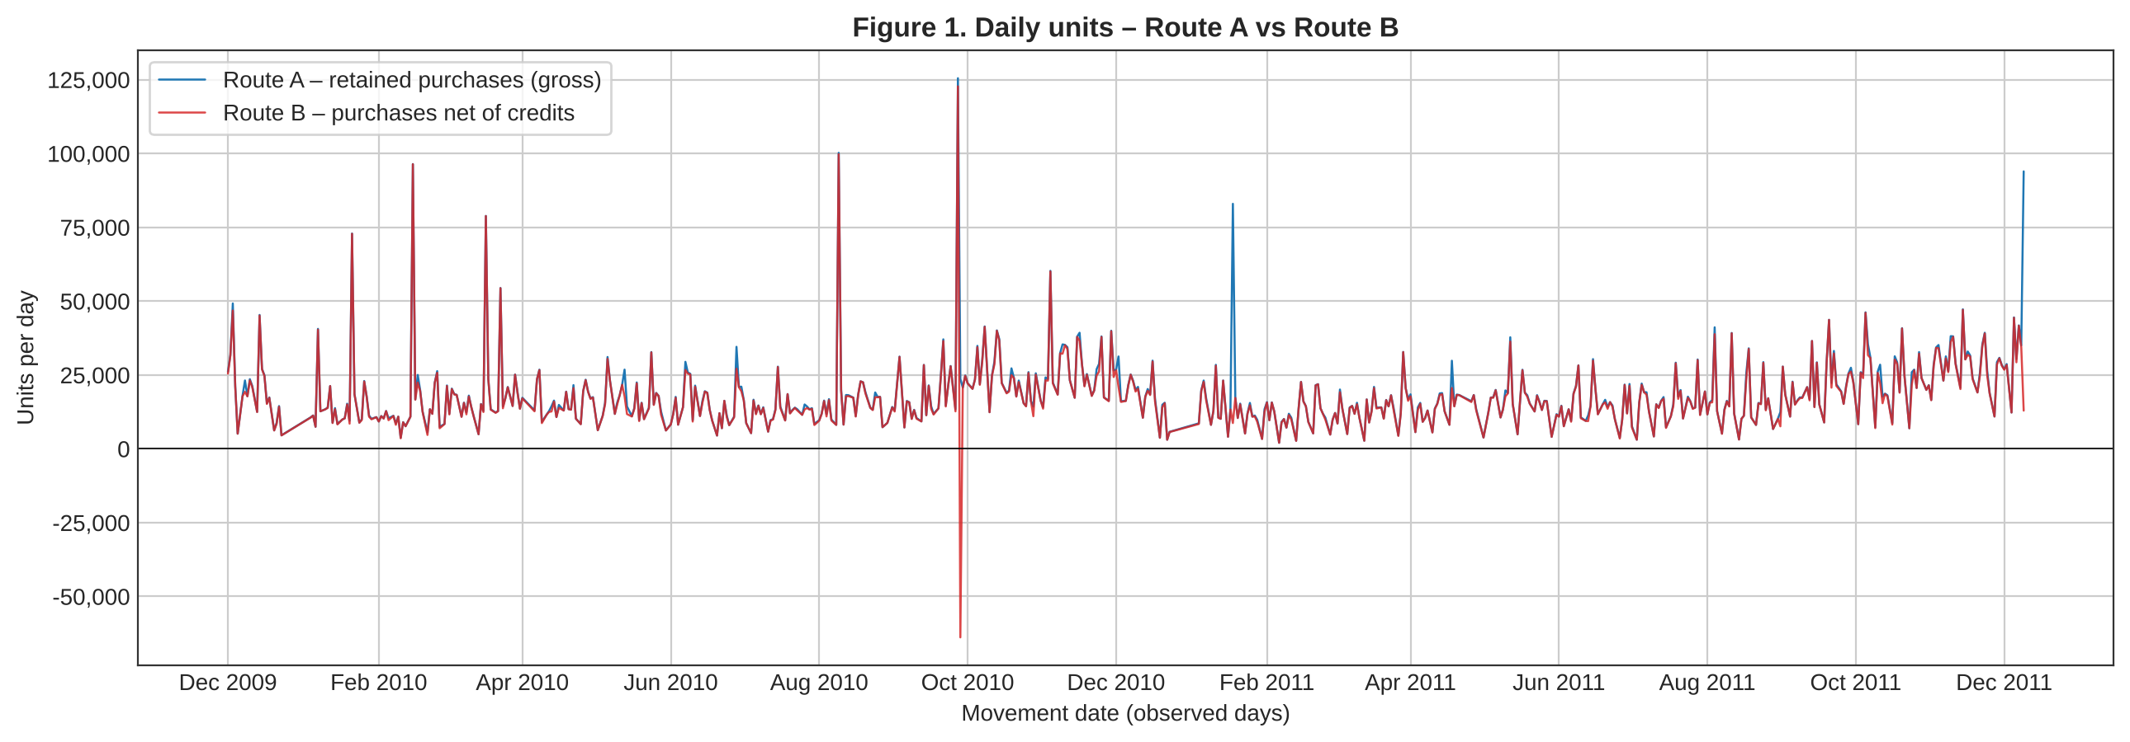
Figure 2 Daily revenue, Routes A and B (GBP)
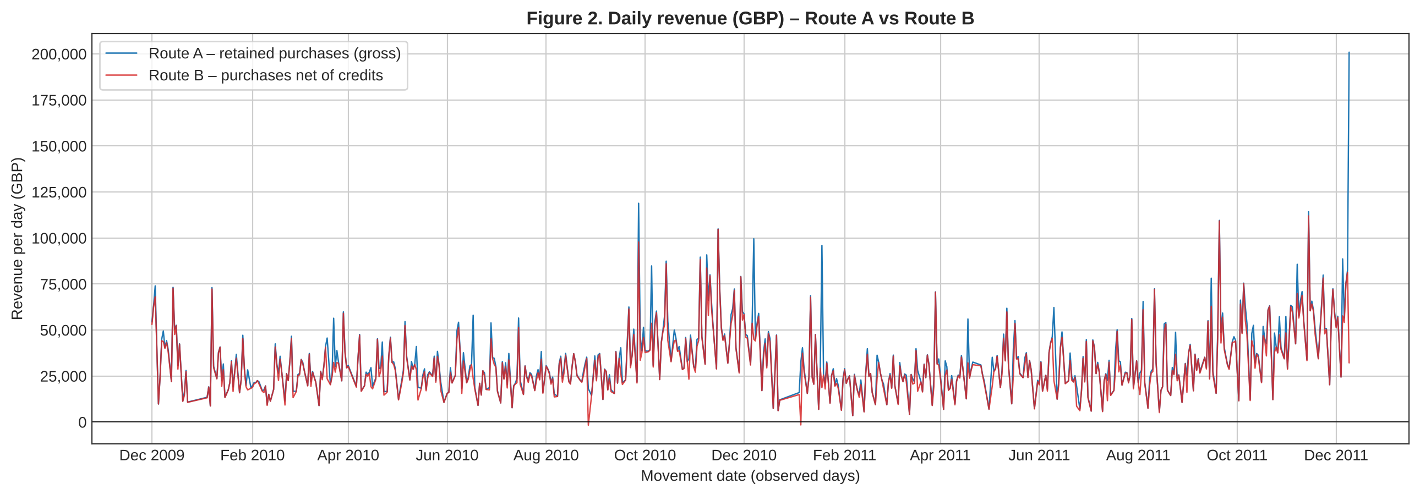
Figure 3 Daily differences B − A in units and revenue
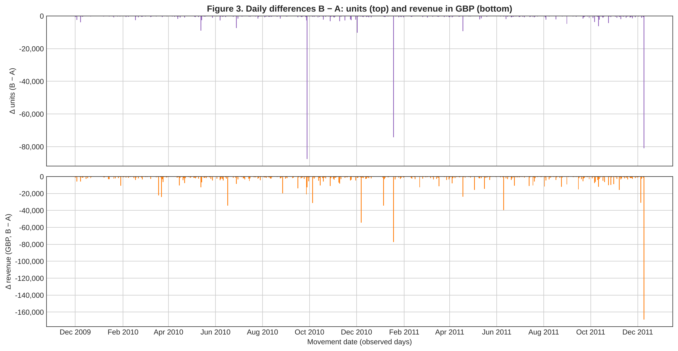
Same dates (604 observed days) and the same scale for A and B within each chart. Lines join consecutive days with data; gaps (Sundays, Christmas closure) are not filled with zeros. Δ is always ≤ 0 because B only adds credits to A's purchases.
For orders, units and revenue compute Δ = B − A and Δ % = 100 × (B − A) / A. Keep the sign; when A is zero, report Not computable for the percentage and report the absolute difference. For the whole period, compute the percentage from the totals, without averaging daily percentages.
Cumulative indicator | A | B | Δ B minus A | Δ % over A
Summed daily orders | 40,077 | 40,077 | 0 | 0.00%
Units | 11,205,148 | 10,728,328 | −476,820 | −4.26%
Revenue in GBP | £20,476,260.45 | £19,013,836.27 | −£1,462,424.18 | −7.14%

Identify the three days with the largest absolute monetary difference and review the credits that explain it. Fill in one row per day. You may add a monthly summary for context.
Date | Δ revenue GBP | Δ % over A | Movements that explain the difference
2011-12-09 | −£168,789.07 | −84.01% (A £200,918.98) | C581484 (customer 16446): −80,995 u. of 23843 PAPER CRAFT, LITTLE BIRDIE at £2.08 = −£168,469.60 (99.8% of Δ). Reconciled with same-day purchase 581483 (09:15, 80,995 u.): order cancelled 12 minutes later. The other 6 lines add −£319.47.
2011-01-18 | −£77,297.25 | −80.56% (A £95,947.73) | C541433 (customer 12346): −74,215 u. of 23166 MEDIUM CERAMIC TOP STORAGE JAR at £1.04 = −£77,183.60 (99.9% of Δ). Reconciled with purchase 541431 (10:01), cancelled 16 minutes later. The other 16 lines: −£113.65.
2010-12-07 | −£54,559.15 | −54.80% (A £99,553.85) | 6 AMAZONFEE credits without customer (C537651 and C537630 for −£13,541.33; C537644 for −£13,474.79, among others) = −£52,784.41 (96.7% of Δ); unreconciled for lack of customer. The same day, A records a positive AMAZONFEE charge (537632, £13,541.33). Rest: M, D and 25 merchandise lines.

1. What is the cumulative difference in revenue and units? Which credits explain the days with the largest difference? Check that B − A matches the sum of recognized credits, given that the purchases and common exclusions are the same.
Answer and interpretation: The cumulative B − A difference is −£1,462,424.18 in revenue (−7.14% over A) and −476,820 units (−4.26%); orders do not change (40,077 in both routes). The check matches exactly: the LineAmount sum of the 19,103 recognized credits is −£1,462,424.18 and their quantity sum is −476,820, because purchases and common exclusions are identical.
The three days with the largest difference add up to −£300,645.47 (20.6% of the total Δ). Two are explained by a single credit each: wholesale orders cancelled minutes after being recorded (23843 on 9-Dec-2011 and 23166 on 18-Jan-2011). These are the ±80,995 and ±74,215 u. extremes already seen in Activity 1. The third (7-Dec-2010) comes from Amazon fee credits without a customer, which are not merchandise returns. Outside those peaks, the effect is a constant discount: Δ ≠ 0 on 598 of 604 days.
2. How does the reading of commercial performance change when returns are recognized? Support your answer with two observed periods. Distinguish a change in purchases from a change caused by credits.
Answer and interpretation: Period 1, January–February 2011: under A, January totals £689,811.61 (−16.03% vs Dec-2010) and February falls −24.25%. Under B, January is £558,448.56 (−25.21%) and February falls only −11.00%. January is the complete month with the largest Δ (−19.04%): A counts as a sale the £77,183.60 purchase cancelled 16 minutes later. Part of February's drop under A is therefore a base effect from a purchase that never held, not a fall in purchases of that size. B separates both effects: purchases (identical in both routes) fall, but January's credits amplify that month's drop.
Period 2, December 2011 (partial, 8 days): A reports £637,808.33 and its best day of the whole series (9-Dec, £200,918.98). Under B the month is £432,719.06 (−32.16%) and 9-Dec drops to £32,129.91, an ordinary day. The peak is a credit movement, not a change in purchases. By contrast, in Nov-2011 the difference is only −3.17%, so the seasonal growth holds in both routes. Conclusion: recognizing credits lowers the level by about 7% and, above all, removes false peaks that A would read as sales records. Partial months should not be compared in level with complete months.
Supplementary table. Monthly revenue summary by route (context only; the daily series are kept in the notebook and the CSVs).
Month | Revenue A (GBP) | Revenue B (GBP) | Δ B − A (Δ %) | MoM change A | B
2009-12 (partial) | £822,483.95 | £796,648.50 | −£25,835.45 (−3.14%) | —
2010-01 | £651,155.11 | £622,479.50 | −£28,675.61 (−4.40%) | −20.83% | −21.86%
2010-02 | £551,504.73 | £530,891.80 | −£20,612.93 (−3.74%) | −15.30% | −14.71%
2010-03 | £830,915.26 | £763,247.24 | −£67,668.02 (−8.14%) | 50.66% | 43.77%
2010-04 | £678,875.25 | £641,521.05 | −£37,354.20 (−5.50%) | −18.30% | −15.95%
2010-05 | £657,705.50 | £613,270.72 | −£44,434.78 (−6.76%) | −3.12% | −4.40%
2010-06 | £749,537.31 | £677,073.87 | −£72,463.44 (−9.67%) | 13.96% | 10.40%
2010-07 | £648,810.27 | £617,365.48 | −£31,444.79 (−4.85%) | −13.44% | −8.82%
2010-08 | £695,251.91 | £654,774.39 | −£40,477.52 (−5.82%) | 7.16% | 6.06%
2010-09 | £921,696.99 | £851,105.96 | −£70,591.03 (−7.66%) | 32.57% | 29.98%
2010-10 | £1,161,902.22 | £1,080,611.48 | −£81,290.74 (−7.00%) | 26.06% | 26.97%
2010-11 | £1,464,293.14 | £1,416,697.20 | −£47,595.94 (−3.25%) | 26.03% | 31.10%
2010-12 | £821,452.73 | £746,723.61 | −£74,729.12 (−9.10%) | −43.90% | −47.29%
2011-01 | £689,811.61 | £558,448.56 | −£131,363.05 (−19.04%) | −16.03% | −25.21%
2011-02 | £522,545.56 | £497,026.41 | −£25,519.15 (−4.88%) | −24.25% | −11.00%
2011-03 | £716,215.26 | £682,013.98 | −£34,201.28 (−4.78%) | 37.06% | 37.22%
2011-04 | £536,968.49 | £492,367.84 | −£44,600.65 (−8.31%) | −25.03% | −27.81%
2011-05 | £769,296.61 | £722,094.10 | −£47,202.51 (−6.14%) | 43.27% | 46.66%
2011-06 | £760,547.01 | £689,977.23 | −£70,569.78 (−9.28%) | −1.14% | −4.45%
2011-07 | £718,076.12 | £680,156.99 | −£37,919.13 (−5.28%) | −5.58% | −1.42%
2011-08 | £757,841.38 | £703,510.58 | −£54,330.80 (−7.17%) | 5.54% | 3.43%
2011-09 | £1,056,435.19 | £1,017,596.68 | −£38,838.51 (−3.68%) | 39.40% | 44.65%
2011-10 | £1,151,263.73 | £1,069,368.23 | −£81,895.50 (−7.11%) | 8.98% | 5.09%
2011-11 | £1,503,866.78 | £1,456,145.80 | −£47,720.98 (−3.17%) | 30.63% | 36.17%
2011-12 (partial) | £637,808.33 | £432,719.06 | −£205,089.27 (−32.16%) | −57.59% | −70.28%

Strategy evaluation and final decision
Aspect | Route A | Route B
Rules applied and reference to the line control | Common base without 34,335 copies; excludes C prefix, Q ≤ 0 and P ≤ 0. Result: 1,007,913 kept + 25,123 excluded = 1,033,036. | The same 1,007,913 purchases as A plus 19,103 C credits (Q < 0, P > 0). Result: 1,027,016 + 6,020 = 1,033,036.
Treatment of cancellations and other negatives | Excludes the 19,104 C lines and the 3,393 negatives without C; no cancellation affects the figures. | Recognizes credits with their sign on their own date, without moving or reducing the original purchase. The C exception and the 3,393 negatives without C (Price 0, no customer) stay outside. Reconciliation by lines: 51.4% reconciled, 28.2% ambiguous, 20.3% unreconciled.
What the revenue indicator represents | Gross sales of retained purchases: £20,476,260.45. Not profit or a financial statement. | Sales net of recorded credits: £19,013,836.27 (−7.14% vs A). Not profit.
Risks and limitations to report to management | Overstates revenue by £1,462,424.18 and units by 476,820. Records as sales orders cancelled minutes later (false peaks on 18-Jan-2011 and 9-Dec-2011). Includes non-merchandise charges: 4,573 lines, £832,284.45 (4.1%), including the A563185 adjustment for £11,062.06. | 50.7% of the credited amount has no identified originating invoice and 9.1% is ambiguous, mostly M and AMAZONFEE without customer. Some days may be net negative. Credits for sales before Dec-2009 reduce months in which that sale did not happen. Shares A's non-merchandise charges.

3. Which route do you recommend for reporting to management and for continuing the analysis? Base your choice on the results, the scope of the indicator and the share of credits without a reliable link. Explain which limitations remain. Do not call Revenue profit; no costs are available.
Final recommendation and selected route: Route B, both for reporting to management and for continuing the analysis (transacciones_procesadas.csv with MovementType Purchase/Credit). C credits are commercial documents with a positive price; leaving them out overstates revenue by £1,462,424.18 (7.14%) and creates sales records that never existed. B keeps the same 40,077 orders and its difference from A equals exactly the credits. It also records every movement on its own date, which avoids rewriting history and information leakage in RFM and repurchase analysis (Activity 3).
Scope and limitations: Revenue is sales net of recorded credits, not profit, because there are no costs. Only 40.2% of the credited amount has a reliable link under the rule. For merchandise, traceability is 73.9%, but for manual or platform charges 90.6% has no link. Therefore part of net sales includes credits without an identified originating purchase. Also remaining: non-merchandise charges within purchases, possible double records among the excluded duplicates, and partial months. We recommend reporting both figures to management (gross A and net B) and validating codes M, AMAZONFEE, BANK CHARGES and A563185 with Finance.

Deliverables
1. Executed .ipynb notebook with both routes, audit and comparisons.
2. This completed report, with tables, charts and final decision.
3. transacciones_procesadas.csv for the selected route, with the original columns, SourceRow, LineAmount, Date and MovementType (Purchase or Credit). Document decisions and added fields; keep the exclusions and their reasons in the notebook.
4. indicadores_diarios.csv for the selected route and indicadores_diarios_comparacion.csv with both routes. Identify any exported audit as a complement.
Export the CSVs without an extra index and keep the nulls. Keep purchases and credits on their original dates; later movements must not rewrite history.
Delivered files: Notebook “NB3 Data Preparation and Processing - Online Retail II.ipynb” (executed); transacciones_procesadas.csv (Route B, 1,027,016 lines: 1,007,913 Purchase + 19,103 Credit; original columns with Customer ID → CustomerID, plus SourceRow, LineAmount, Date and MovementType); indicadores_diarios.csv; indicadores_diarios_comparacion.csv. Complements: auditoria_conciliacion_abonos.csv (one row per credit), registro_exclusiones.csv (SourceRow, stage and reason for every exclusion) and resultados_informe.json (figures in this report).

References
Chen, D. (2012). Online Retail II [Dataset]. UCI Machine Learning Repository. https://doi.org/10.24432/C5CG6D
North Quay Gifts Case Study. Provided material. https://docs.google.com/document/d/1luKfmlQgW3RHrsZAIXC30ydZrni3wRQvnw8s3VlLRss/edit

